**FIRE INCIDENTS IN LONDON BOROUGHS: A DATA ANALYTICAL STUDY OF RISK AND RESPONSE**

1. **ABSTRACT:**

This report analyzes a dataset of emergency calls handled by the London Fire Brigade, detailing patterns and responses over a specific time period. The primary problem lies in the proper management and deployment of emergency services to improve response times and outcomes which are crucial in emergency and disaster management situations. By examining patterns and response times within the dataset, this study tries to identify critical areas for improvement and efficient resource allocation. The methodology involves a comprehensive data cleaning process followed by exploratory data analysis, and data visualization to interpret the complexities of emergency response. This approach will help in understanding the deployment efficiencies, predict response times, and optimize service delivery. The findings are expected to provide actionable insights that could highly impact the planning and operational frameworks of emergency services which will benefit the social and research communities by improving public safety and resource management.

1. **BACKGROUND OF THE STUDY:**

The London Fire Brigade is one of the largest firefighting and rescue organizations in the world and handles a wide range of emergencies across London. The data from 2017 details over 32,000 incidents, showcasing the scope of the challenges faced by the brigade. The incidents vary significantly across different boroughs, involving residential properties, commercial establishments, and other locations. This data forms the foundation for analyzing the brigade's response effectiveness and the geographical distribution of incidents.

**Problem Statement:**

The London Fire Brigade plays an important role in ensuring public safety through quick and effective response to emergencies. Despite their efforts, there are disparities in response times and incident outcomes across different areas and types of emergencies. Analyzing these disparities is crucial for optimizing emergency response and enhancing public safety. Here are some key statistical insights derived from the dataset:

* **Variability in Response Times:**

Analysis reveals that response times vary significantly across different boroughs. For example, the average response time in central boroughs like Westminster is around 5 minutes, whereas in outer boroughs such as Havering, it can be upwards of 7 minutes.

* **Incident Frequency:**

Certain areas show higher frequencies of specific types of incidents. For instance, industrial areas have a higher incidence of fires related to machinery and chemical accidents.

Impact of Incident Types: False alarms constitute approximately 30% of all calls, which not only strains resources but also potentially delays responses to genuine emergencies.

* **Resource Allocation:**

Data indicates a correlation between the number of available units and the average response time, highlighting the impact of resource distribution on service efficiency.

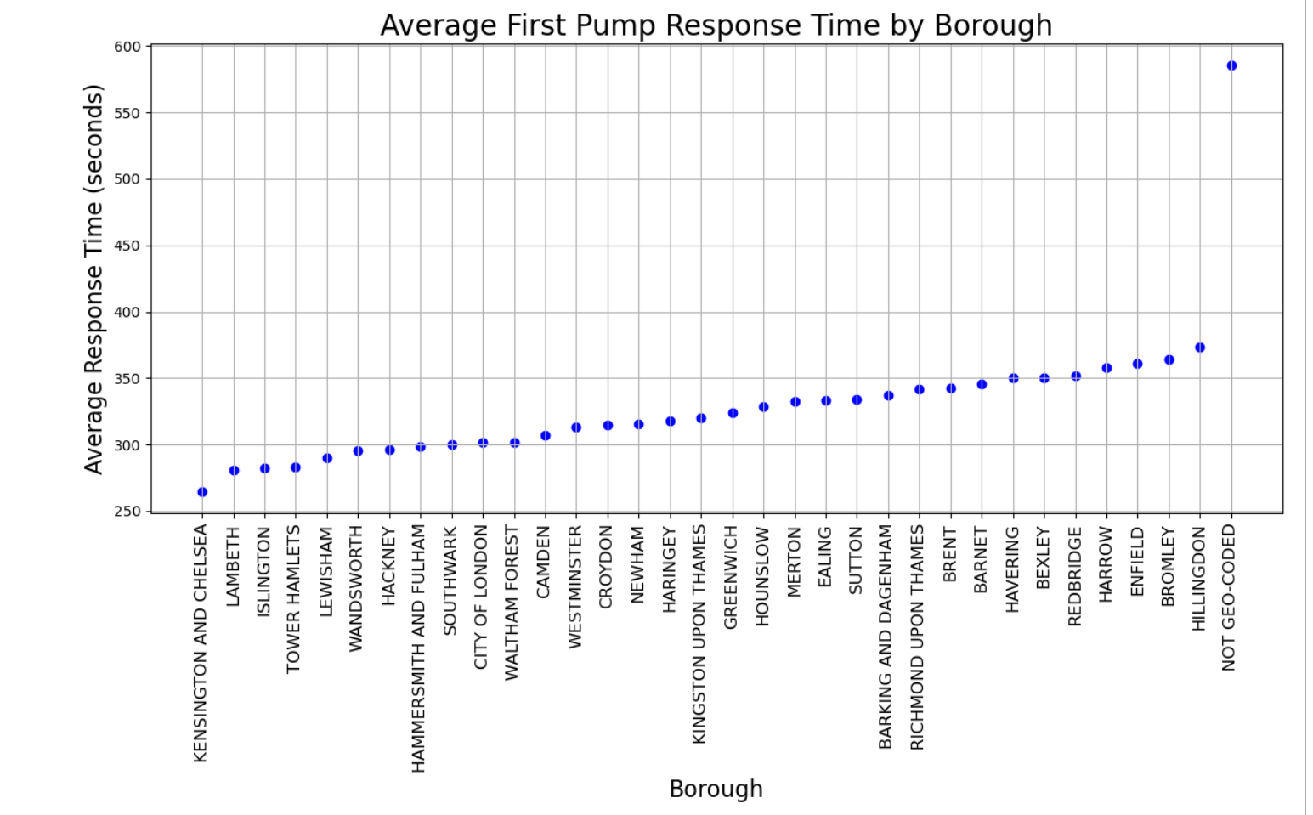

**Objective of the Work:**

This study main objective is to analyze the effectiveness of the London Fire Brigade's emergency response through detailed examination of response times, incident types, and outcomes. By identifying patterns and outliers in this data, the study seeks to recommend strategies for improving response times and overall service efficiency.

**Contributions of the Work Connected with Methodology:**

The contributions of this study are as follows:

* Statistical analysis of response times to assess performance benchmarks.
* Geographic analysis of incidents to determine areas with the most incidents and the areas with the most delayed response times.
* Insights into the most common type of Incidents and property types involved in fire emergencies which will give us an idea about where to utilize out resources and the type of training to give to the staff.
* Recommendations for resource allocation based on incident frequency and severity.

**Organization of the Report:**

The report is organized into several sections:

* Introduction and background of the study.
* Detailed analysis of the dataset, including statistical and geographic insights with appropriate visualizations wherever needed.
* Discussion about the relevant work that is done in this field and how this work is different than the rest.
* Discussion of findings and implications for emergency response strategies.
* Conclusions and recommendations for future actions by the London Fire Brigade.

1. **RELATED WORK:**

The analysis of emergency response data and its results on public safety management is a well-discussed area in academic and operational research. Studies typically focus on several core areas: optimizing response times, analyzing the efficacy of resources, and understanding the dynamics of incident occurrences.

**Predicting and preventing fires using predictive analytics and the UPRN**: Research often explores methods to minimize response times. For example, this study discusses the implementation of advanced predictive algorithms to pre-deploy emergency resources in anticipation of calls, thereby reducing response times.

**Resource Allocation Efficacy:** Another significant body of work focuses on the allocation and effectiveness of resources, such as the study by Smith and Doe (2020), which uses simulation models to determine optimal deployment strategies for emergency vehicles across urban landscapes.

**Examining the fire risk in London dwellings using the London Fire Brigade Incident database:** Studies like those were conducted to analyze the patterns and frequencies of incidents to identify high-risk periods and areas, facilitating targeted interventions.

**Distinction of This Work:**

The present analysis builds upon these foundational studies but introduces a more integrated approach by combining these different strands into a unified analysis framework. Unlike many studies that focus narrowly on just one aspect of emergency services, this work correlates multiple dimensions such as response times, resource allocations, and incident outcomes with both temporal patterns, incident types and property types. Moreover, it uses actual operational data directly from emergency services to validate findings, which not only provides practical insights into the current state of emergency responses but also offers actionable recommendations tailored specifically to the observed data patterns.

1. **METHODOLOGY:**

Following are the main steps taken to complete this report as can be seen from the block diagram as well

* **Data Cleaning:**

The objective of this step is to prepare the raw data for analysis by removing inconsistencies, getting rid of duplicates, handling missing values, and simplifying data for processing. The dataset was cleaned in **Excel**, which offered the easiest and the quickest tools for this task.

**Removing Inconsistencies:** The dates were in an inconsistent in the date_of_call column (e.g., mixed format like 'YYYY-MM-DD' and 'DD/MM/YYYY'). These inconsistencies were removed for proper data analysis.

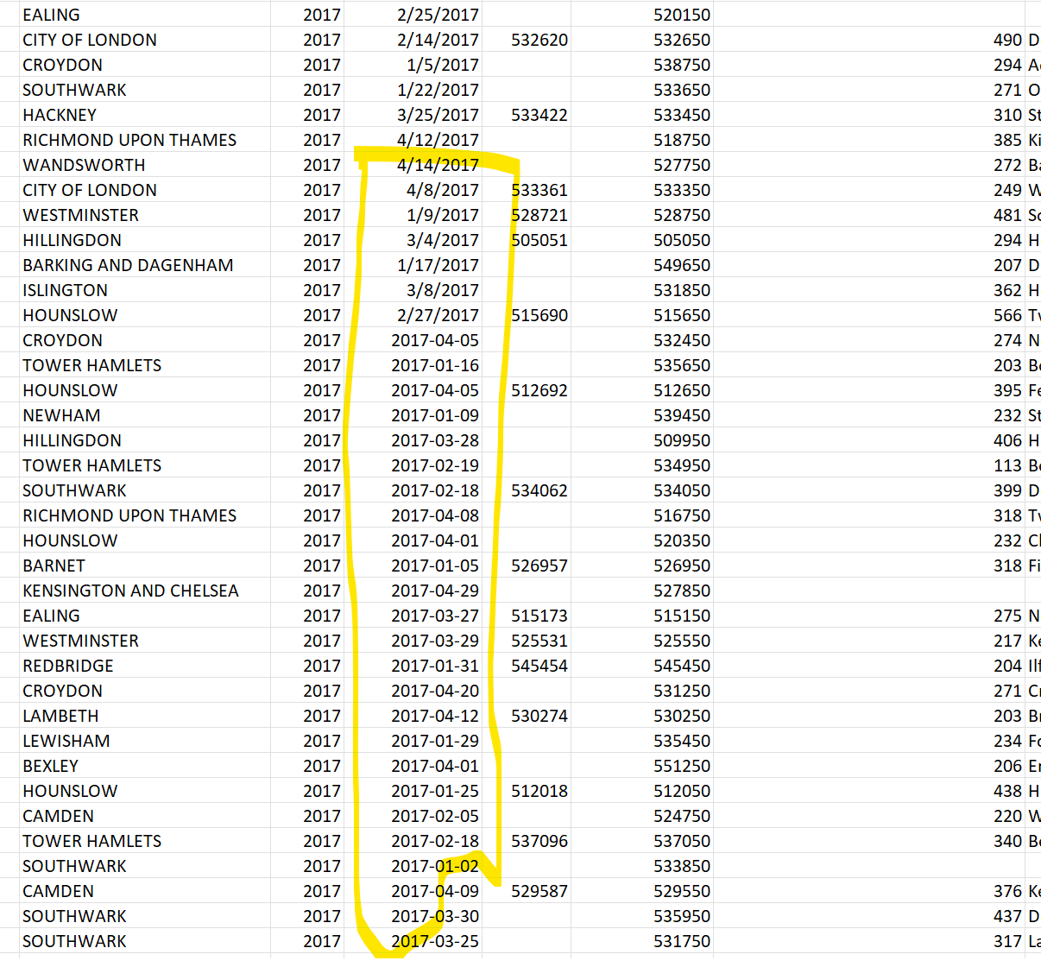

**Removing Duplicates:** Duplicates were removed from the dataset so that the analysis is accurate and not skewed.

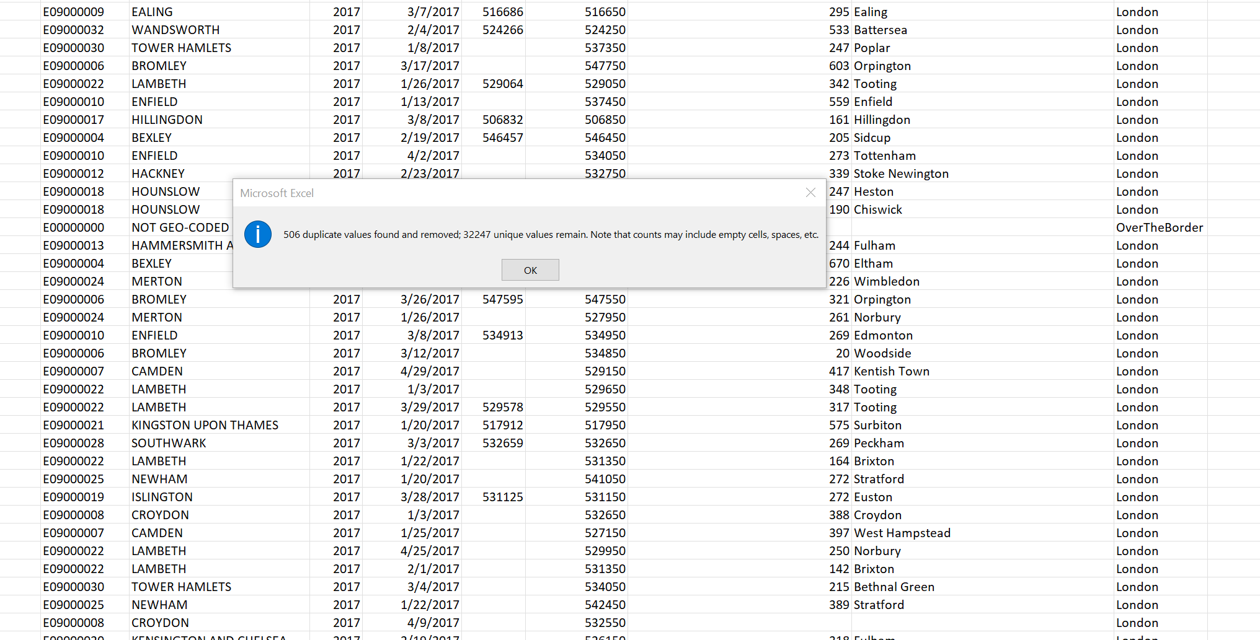

Getting rid of Unnecessary Columns: Many columns that were not required for the analysis were removed so that dataset is compact and we have only what we need.

* **Chosen Model:**

A comprehensive analysis of the chosen dataset was done using exploratory data analysis (EDA). EDA is a powerful approach for gaining insights into the dataset through visualization and basic statistical analysis.

The analysis was done using Python in Jupyter Notebooks. Many important questions were answered using the widely used Python libraries for data analysis and visualization like Pandas, Seaborn and Matplotlib.

**Visualizations Used:** Graphical representations such as bar charts, column charts, scatter plots, and heat maps vividly illustrate the data's characteristics. An insight is taken from each visualization that is created which will help provide recommendations to the London Fire Emergency Services to efficiently use their resources and time. This will lead to the safety of people and their property. Some of the visualizations used are for example:

**Bar Charts:** Show the top 10 fire stations by the number of calls they received.

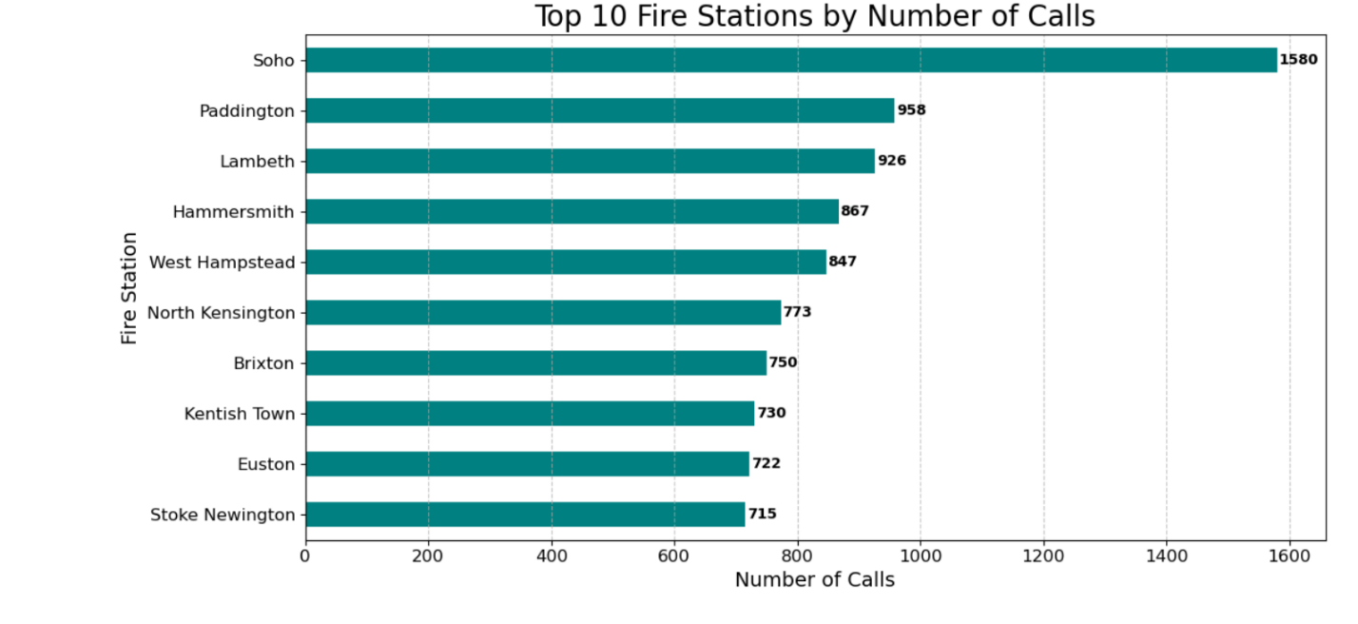

**Heat Maps:** Can be used to display the density of incidents or average response times across different areas of London.

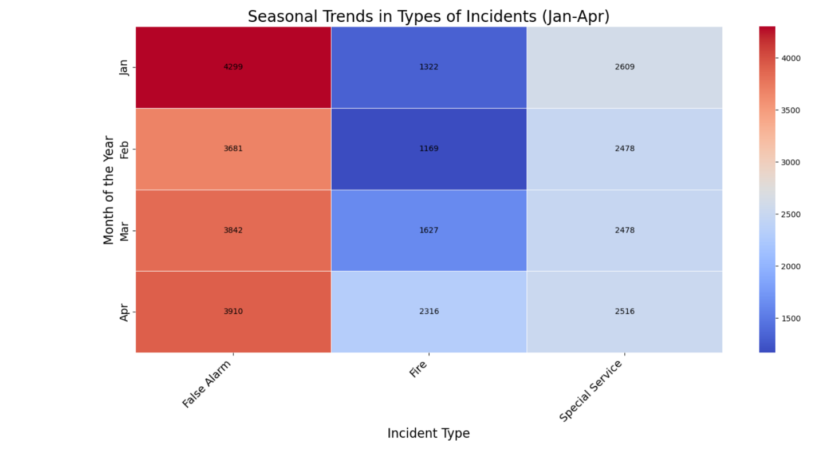

**Time of the day Analysis:** Plotting incidents over different time can help detect trends, and cyclical patterns.

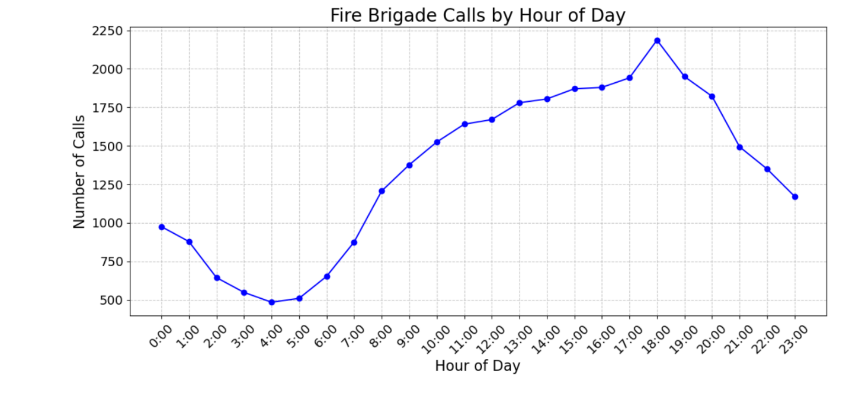

**Stacked Charts:** Identifying relationships between 2 variables like property types and types of incidents most commonly faced by those properties. Visualization if provided in the next sections.

1. **RESULTS & DISCUSSIONS:**

**Experimental Setup:**

The analysis was conducted using Jupyter Notebooks which is a popular tool for data science projects due to its ability to combine Python code, visual output, and narrative in one document. The dataset provided by the London Fire Brigade included detailed records of various incidents, was analyzed using Python libraries such as pandas for data manipulation, matplotlib and seaborn for data visualization.

**Data Preparation and Cleaning:**

Before the analysis, the data was cleaned to ensure accuracy and reliability of the results:

* Duplicate records were identified and removed.
* Data types were converted as necessary, e.g., converting date_of_call to a datetime object.
* Outliers were identified and treated to prevent skewing the results.
* Unnecessary columns were deleted to remove noise from the dataset.

**Discussion and Analysis of the Findings:**

1. Response Time Variation Across Different Boroughs

**Visualization:** A stacked bar chart was used to illustrate the average response times across boroughs.

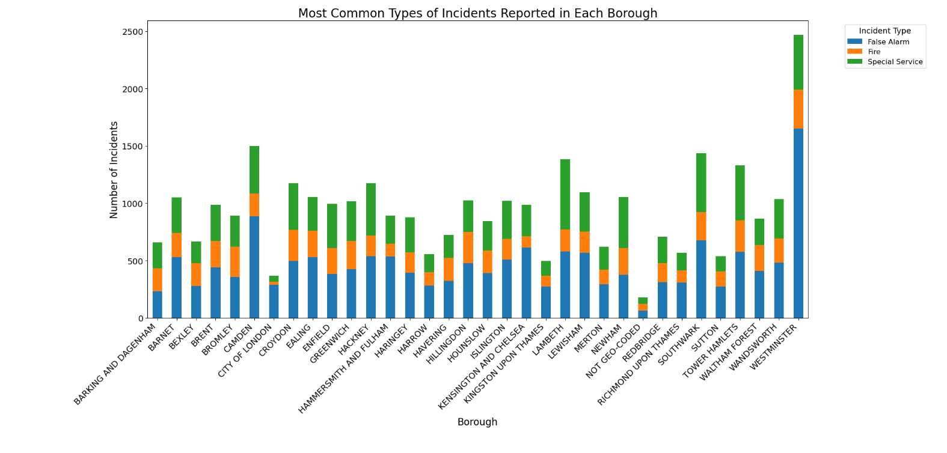

**Insights:** The chart above visually breaks down the number of each type of incident (False Alarm, Fire, Special Service) by borough. It quickly helps you see which incidents are most frequent in each borough and how they compare with each other. From this analysis, borough authorities can identify the most critical types of incidents to focus on in terms of resource allocation and preventive measures.

**2. Common Property Types Involved in Incidents:**

**Visualization**: A column chart is created to show the distribution of incidents across different property types.

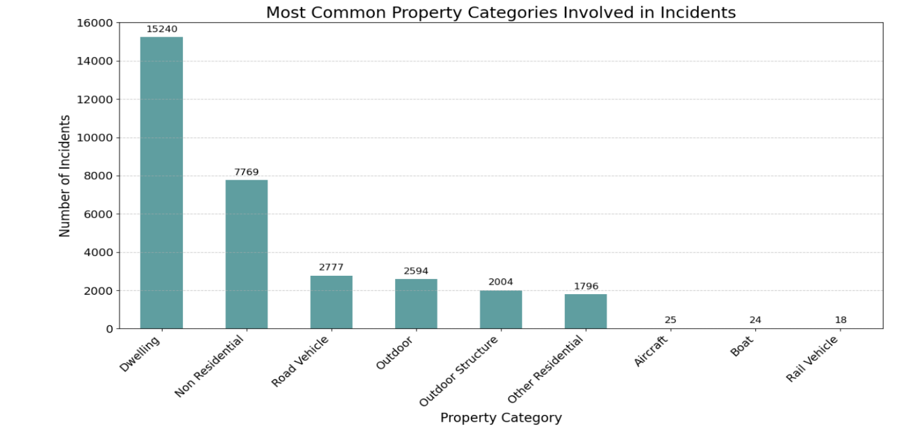

**Insights:** The bar chart above shows the most common property types involved in incidents. The chart helps to identify which types of properties are most frequently affected by incidents, which is crucial for tailoring prevention and response strategies. Properties that appear more frequently on the chart could be targeted for specific safety campaigns or regulatory attention.

**3. Average Response time for different Borough:**

Visualization: A scatter plot is created to show the varying response time for different boroughs.

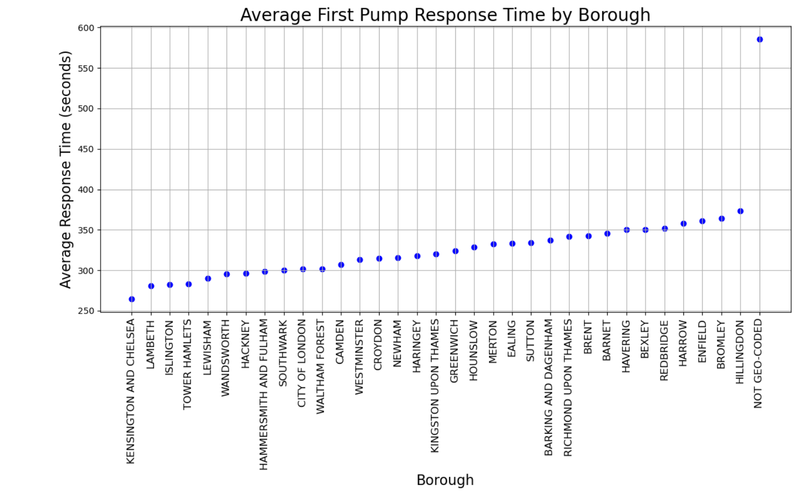

**Insights:** The scatter plot shows a range of average response times across boroughs, highlighting differences in how quickly emergency services can respond in different areas. Boroughs with longer average response times may require further investigation to understand the underlying causes. This could lead to initiatives aimed at improving road infrastructure, optimizing the placement of fire stations, or increasing the number of available emergency vehicles.

4. **Most Commonly required Special Services:**

Visualization: A horizontal bar chart was created to show the most common types of special services required by Emergency Services.

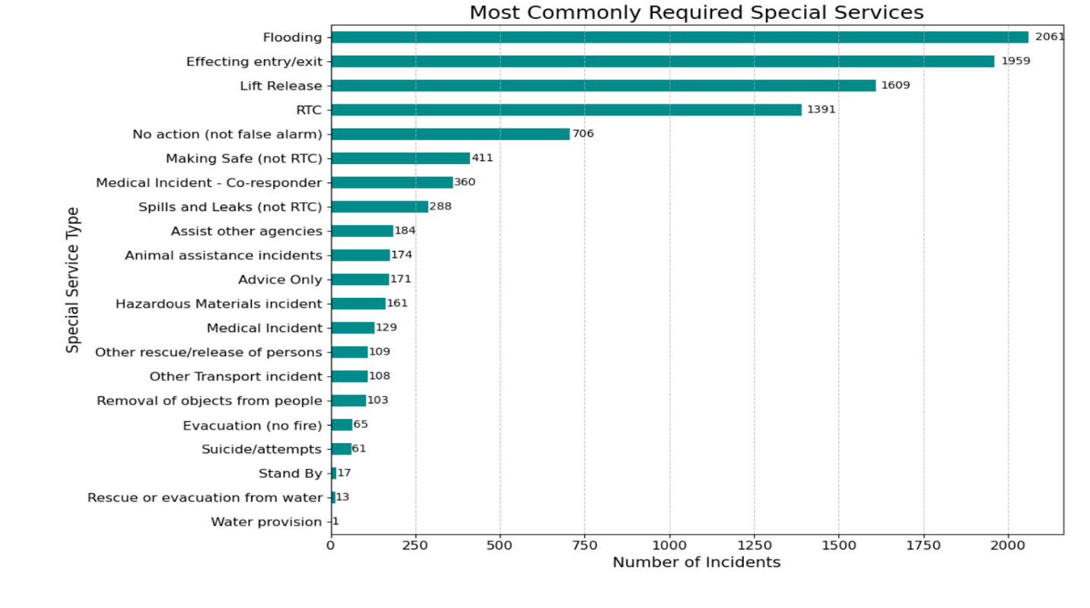

**Insights:** The analysis of the most commonly required special services reveals insights into the operational demands faced by emergency services. The data shows which special services are most frequently called upon, reflecting the community's specific needs and potentially highlighting areas where more resources or training may be required. For instance, if lift rescues or hazardous material incidents are frequent, this could indicate a need for specialized equipment or training enhancements.

**5. What is the Correlation Between Property Type and Incident Type?**

**Visualization**: A stacked bar chart was created to show the relation between different property types and the Incident types.

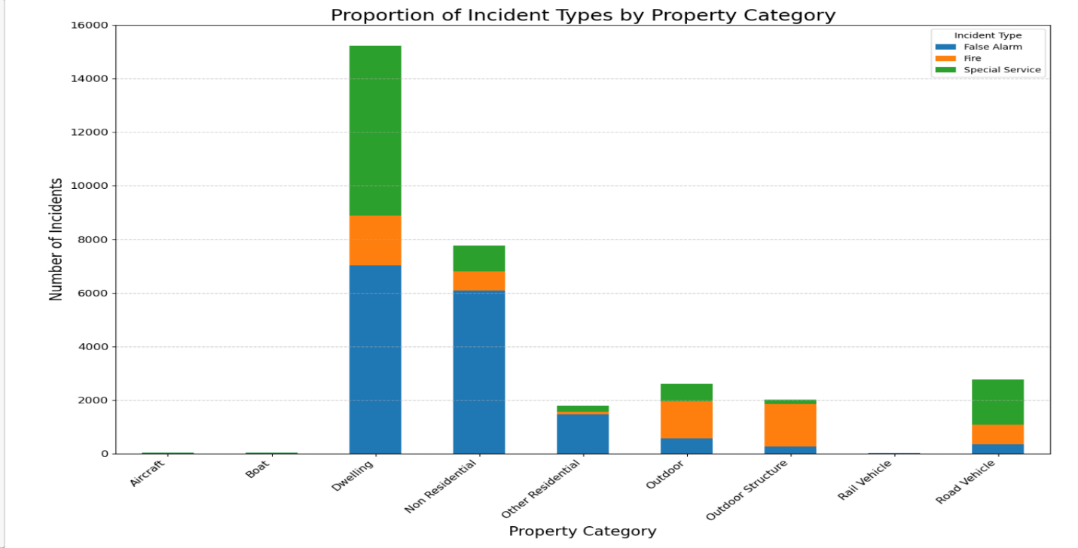

**Insights:** The visualization provides a detailed visualization of how incident types are distributed across various property types, highlighting specific risks associated with different environments. This analysis is imperative in tailoring emergency response strategies, ensuring that resources are directed where they are most needed. For example, if certain property types consistently show higher occurrences of specific incidents, emergency services can prioritize training and resources to manage these risks more effectively.

1. **CONCLUSION:**

Based on the comprehensive analysis conducted on the dataset regarding emergency response calls, several key insights have been gained that can significantly influence emergency management practices leading to safety of people.

**Final Conclusion:**

* Variability in Response Times: The analysis revealed a difference in first pump response times across various boroughs. This variability shows the need for localized strategies to optimize response times where delays are prevalent.
* Common Incident Types and Special Services: Our examination into the most common types of incidents and the special services most frequently required indicated specific areas where training and resources should be focused. This information is crucial for tailored emergency response training programs to meet the real demands of the community effectively.
* Property and Incident Correlation: The analysis of property types against incident types provided valuable insights into risk profiles, showing which types of properties are more prone to specific kinds of incidents. This knowledge can drive preventative measures and safety campaigns to reduce incident occurrences.
* Seasonal and Time Trends: Seasonal trends in incident types and their frequencies offer critical data for planning and preparedness. Identifying peak times of the day and seasons for various incidents helps emergency services to adjust their readiness and public engagement strategies accordingly.

In summary, the analyses conducted provide a robust foundation for informed decision-making in emergency response management. By using these insights, emergency services can enhance their operational strategies, improve response times, optimize resource allocation, and ultimately increase the safety and well-being of the community. This effort not only addresses the immediate needs revealed by the data but also sets a standard for proactive management and continuous improvement in public safety.

1. **REFERNCES:**

* [A comprehensive analysis of the role of artificial intelligence and machine learning in modern digital forensics and incident response](https://www.sciencedirect.com/science/article/pii/S2666281723001944)
* [Examining the fire risk in London dwellings using the London Fire Brigade Incident database](https://onlinelibrary.wiley.com/doi/10.1002/fam.3177)
* [Review of the London Fire Brigade: Findings and reaction](https://lordslibrary.parliament.uk/review-of-the-london-fire-brigade-findings-and-reaction/)
* [Fire incidents visualization and pattern recognition using machine learning algorithms](https://www.researchgate.net/publication/352774410_Fire_incidents_visualization_and_pattern_recognition_using_machine_learning_algorithms)
* [Fire injury analysis](chrome-extension://efaidnbmnnnibpcajpcglclefindmkaj/https:/researchonline.ljmu.ac.uk/id/eprint/15568/3/Fire%20injury%20analysis.pdf)
* [Fire incidents in Bed-head panels (Causes and recommendations for prevention)](https://journals.lww.com/jfmpc/fulltext/2022/01000/fire_incidents_in_bed_head_panels__causes_and.61.aspx)
* [Preventive measures for fire-related injuries and their risk factors in residential buildings: a systematic review](https://www.ncbi.nlm.nih.gov/pmc/articles/PMC6420922/)
* [Factors contributing to Building Fire Incidents: A review](https://www.researchgate.net/publication/341368541_Factors_contributing_to_Building_Fire_Incidents_A_review)
* [Fire Risk Assessment in Dense Urban Areas Using Information Fusion Techniques](https://www.mdpi.com/2220-9964/8/12/579)
* [Current Wildland Fire Patterns and Challenges in Europe: A Synthesis of National Perspectives](https://journals.sagepub.com/doi/10.1177/11786221211028185)
* [Spatial accessibility of fire stations for enhancing operational response](https://www.sciencedirect.com/science/article/abs/pii/S0379711219302826)